|  |  |  |  |  |  |
| --- | --- | --- | --- | --- | --- |
| Date | 9-Dec-22 | | | Tester Name | Mohammad Yusuf |
| Environment | Penfax - Test | | | Login used |  |
| Operating System | Windows | Version: | Update: | | |
| Software Used | Select Software | Version: | Update: | | |
| Select Software | Version: | Update: | | |
| Release version |  | | | | |
| Title |  | | | | |
| Test Type | Regression | | | | |
| Test Scenario |  | | | | |
|  |  | | | | |
| Expected Results |  | | | | |
| Pass/Fail | Select | | | JIRA# | N/A |

Describe your steps with screenshots:

Voluntary money to RRSP

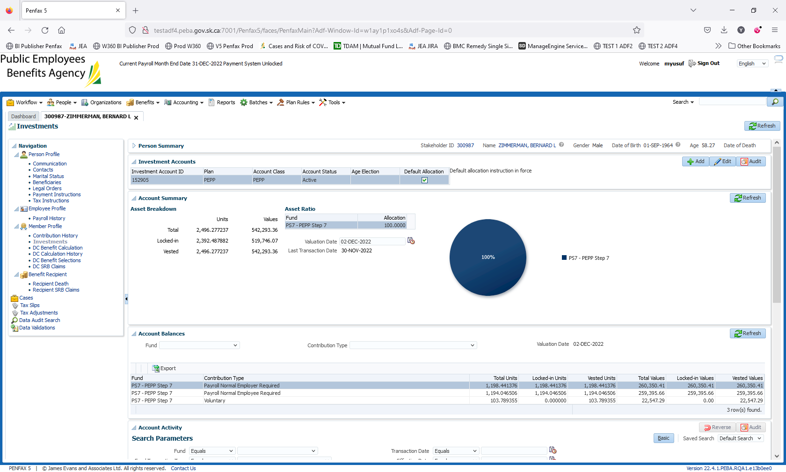

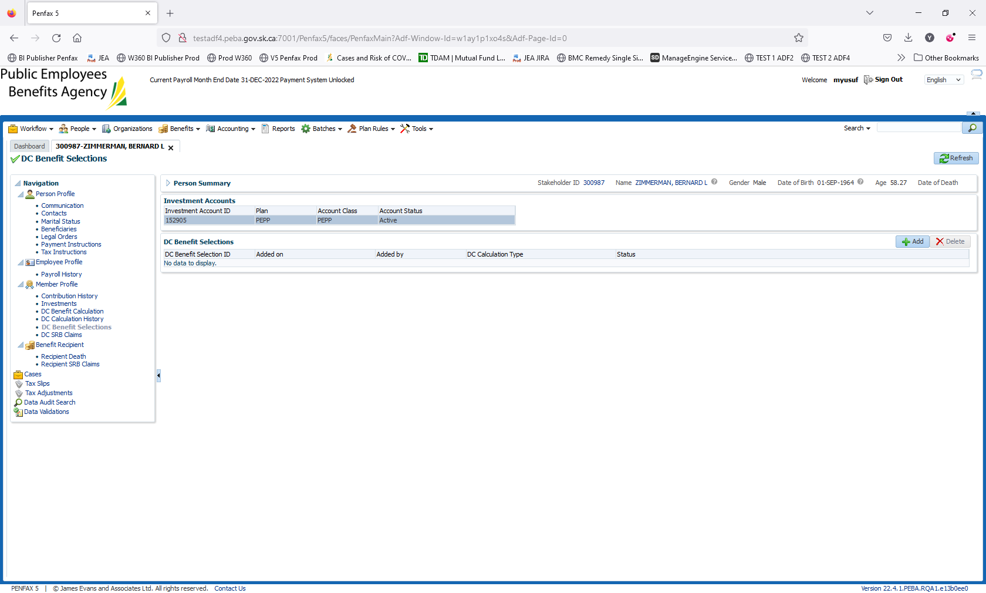

If 50 above, always try to add retirement date as of processing date

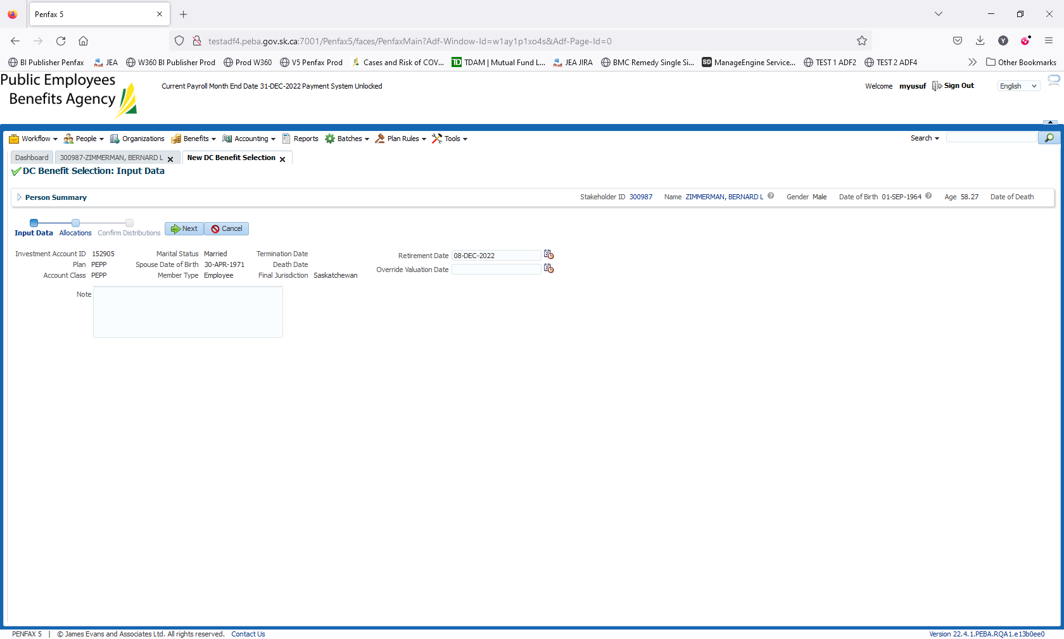

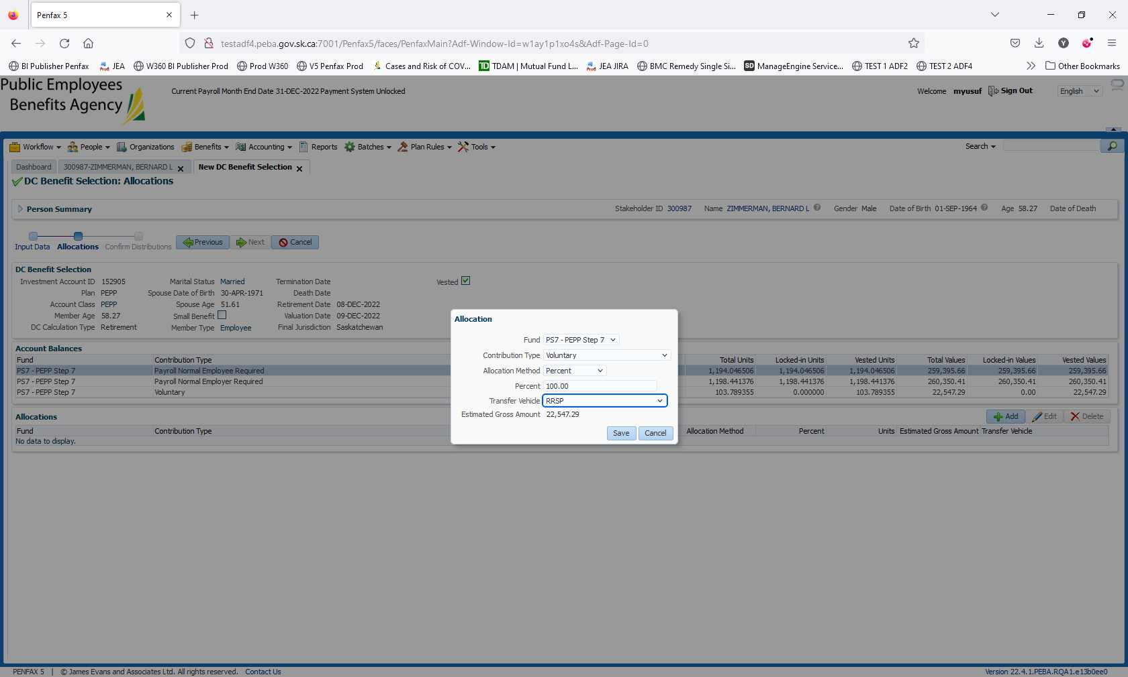

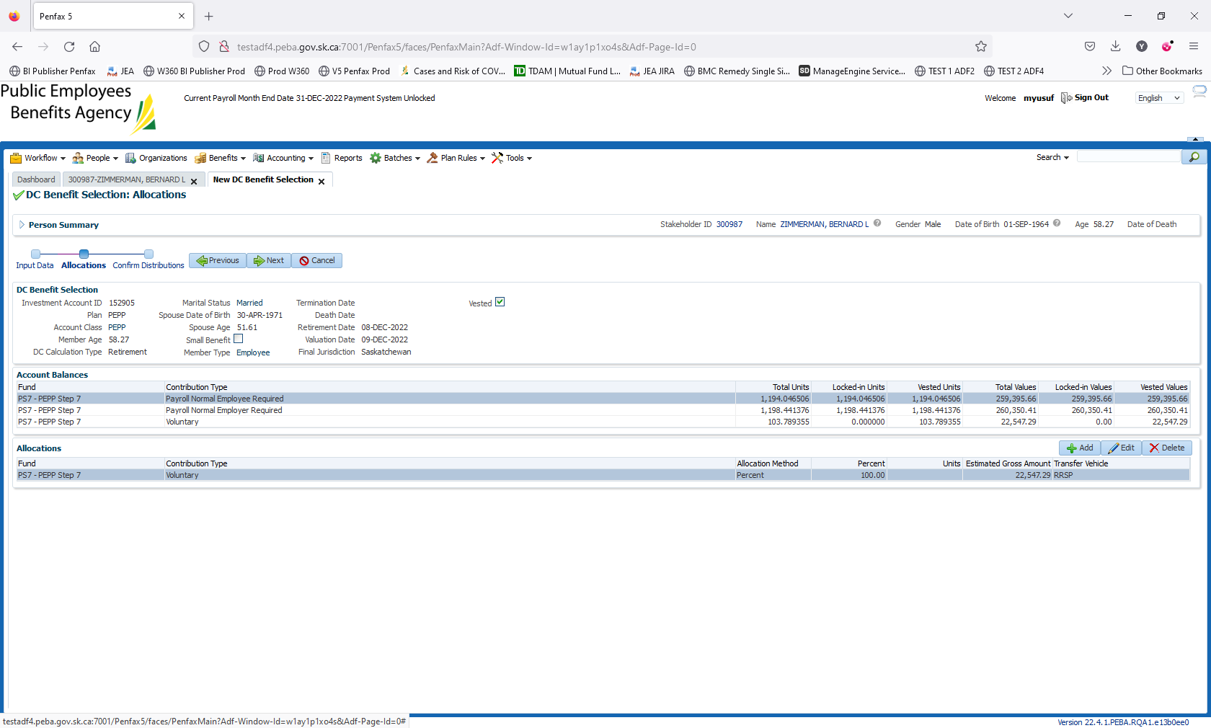

Save the instructions

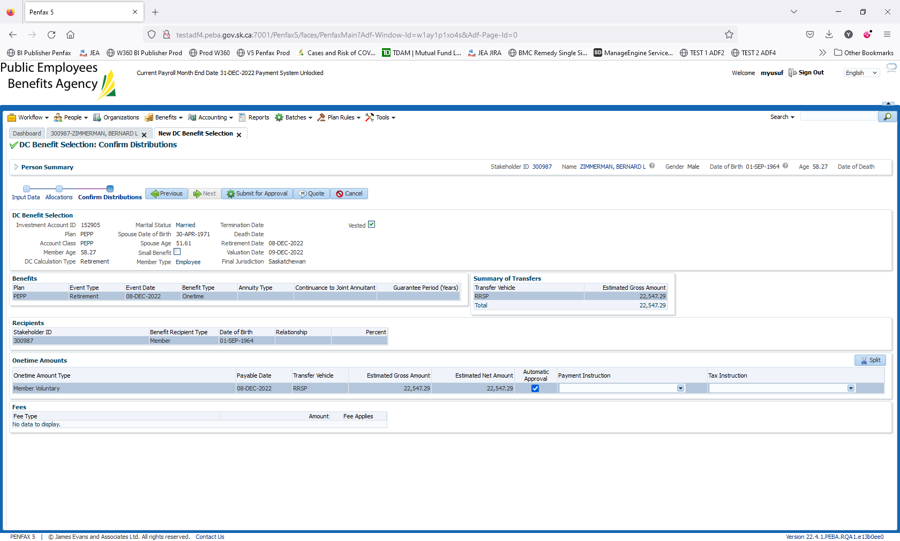

For transfer out, there will be no Tax instructions. We add only Payment instructions as per the client institution selected

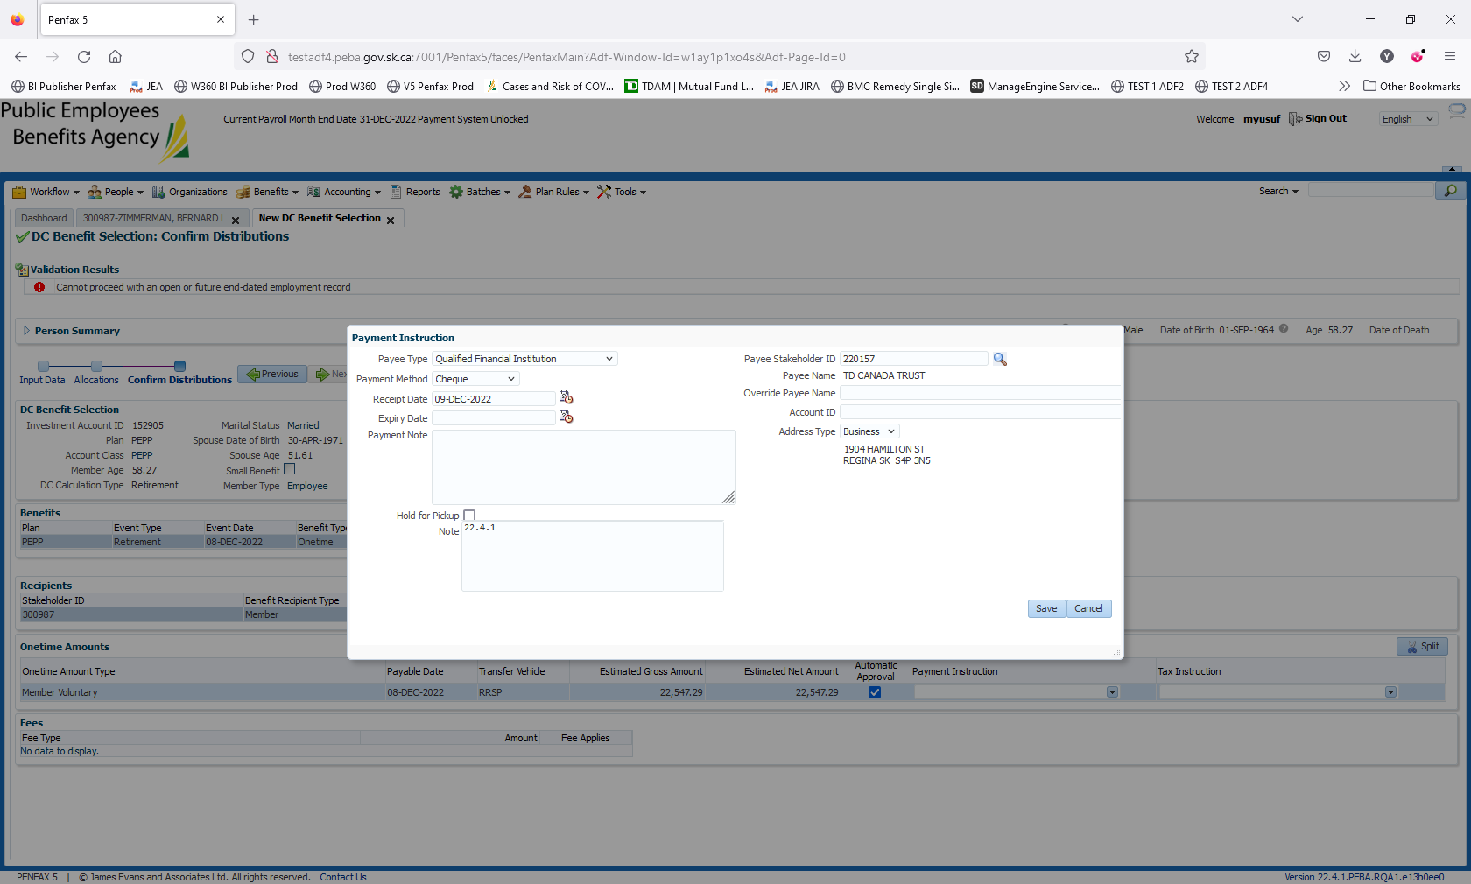

Save it. Changed the Receipt Date to 01-Dec-2022. Added the End date for Employment Periods

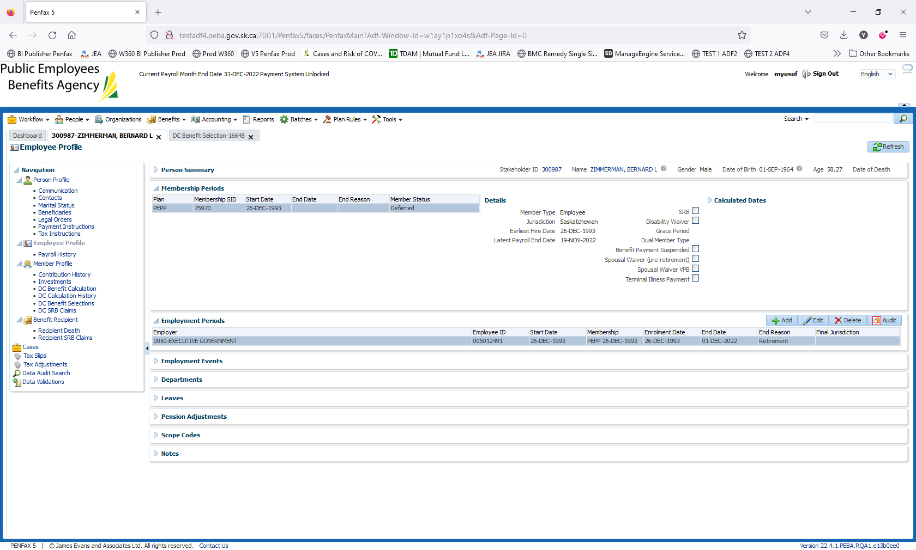

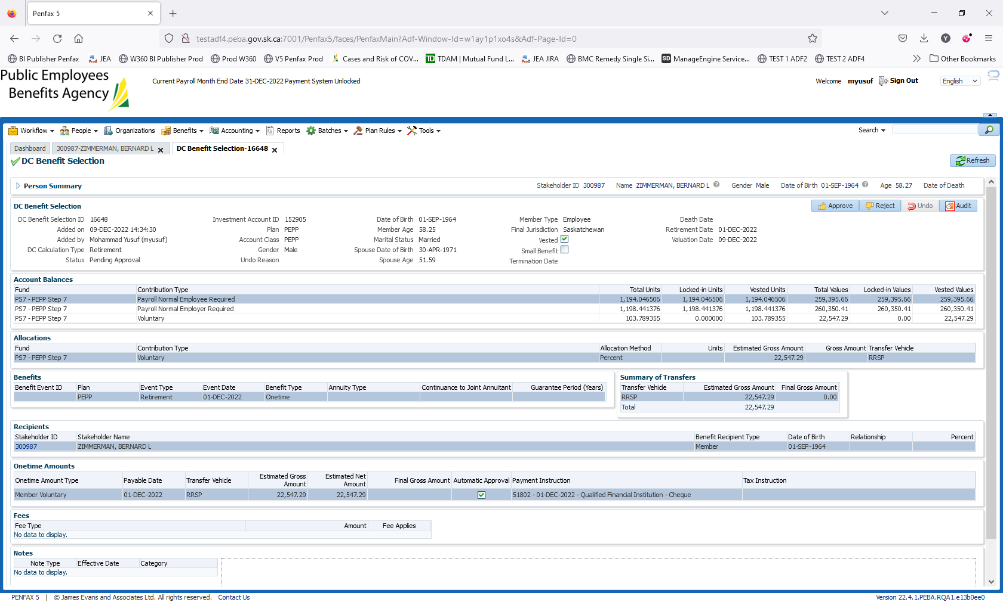

Approve it

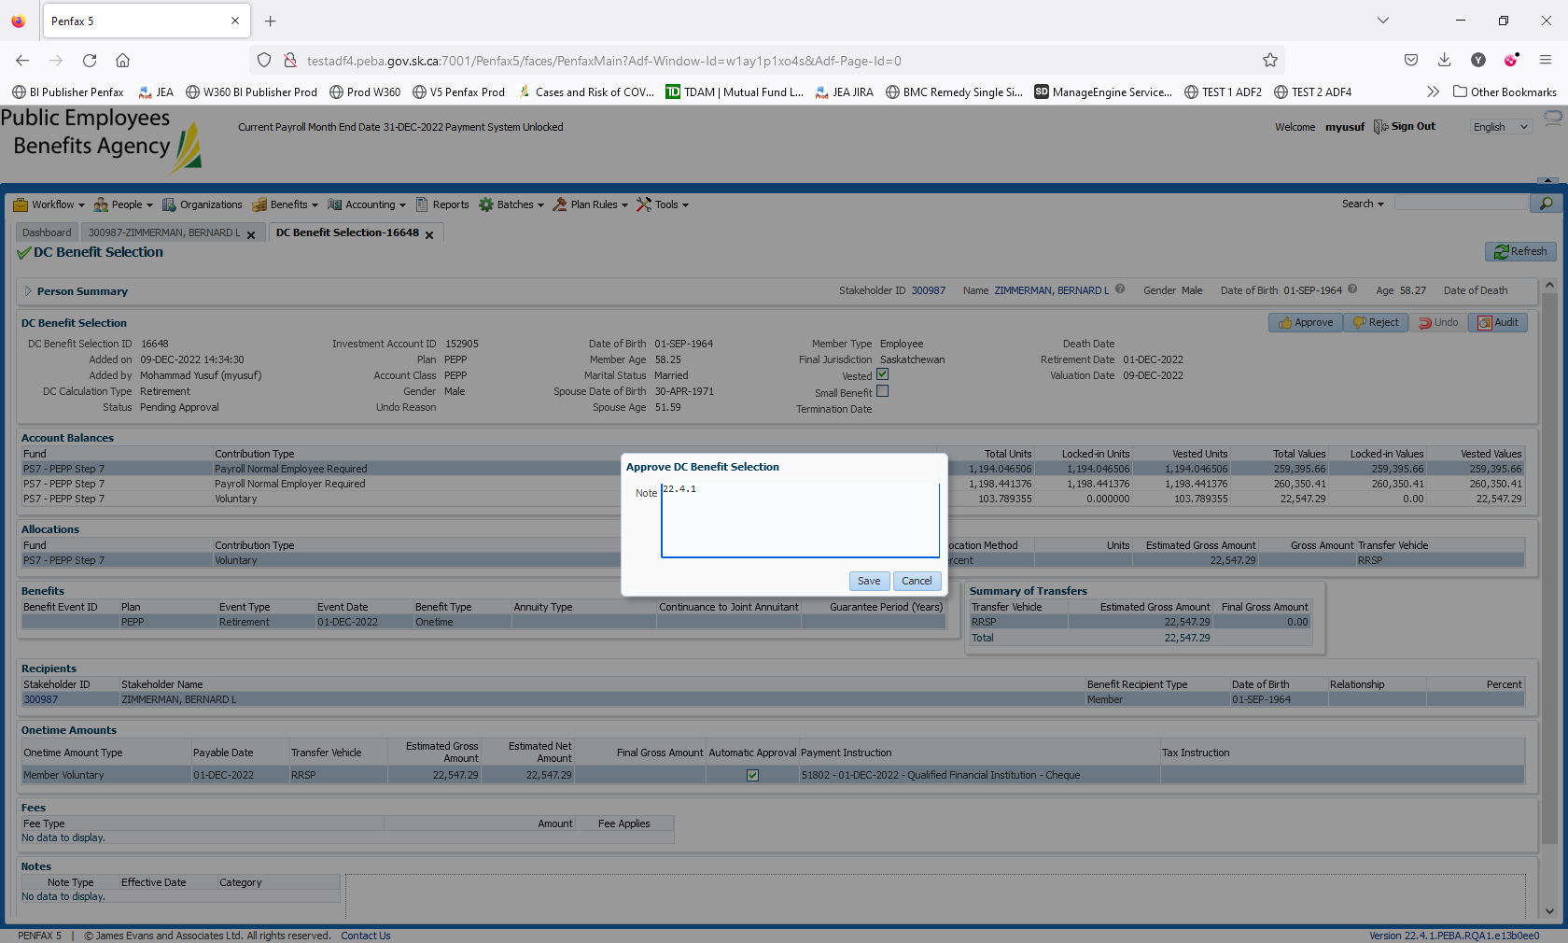

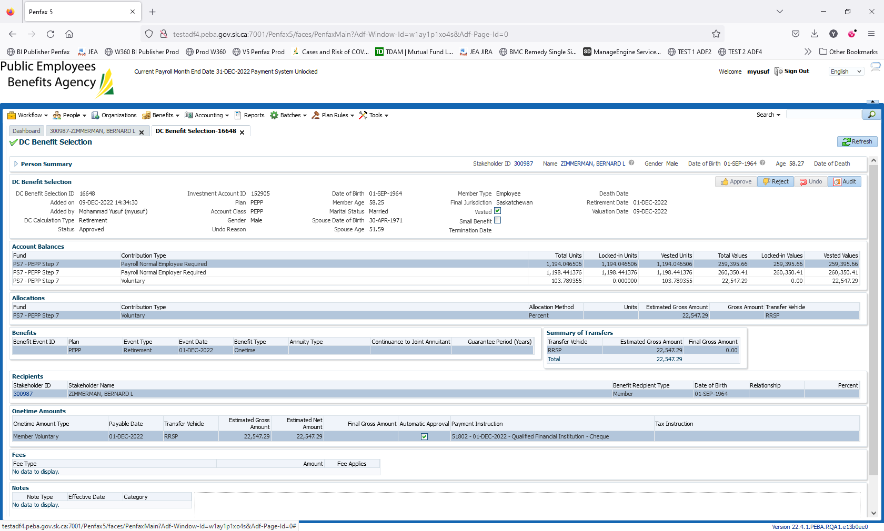

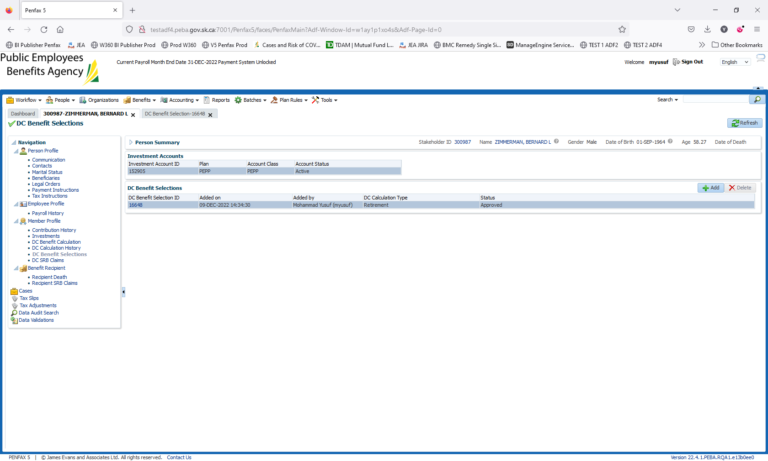

Result as expected

Next day validation

